Year 11 Mathematics Specialist
2018 Revision Assignment 1
In Class

Instructions: to be completed at home, Calculators are permitted
SHOW ALL WORKING
Time Allocation: 50 minutes
Name: _______________ Total Marks: 40 marks

- (5 marks: 3,2)
80 students were asked in a survey if they had previously broken their leg and/or broken their arm. Information from the survey indicated that 30% of students had broken arms, one quarter of those surveyed had suffered broken legs and 30% had not previously broken an arm of leg. How many students had:

- Broken an arm and a leg?

- Broken an arm, but not a leg

- (12 marks: 1, 3, 2, 3, 3)
A committee of 7 people are to be selected from 8 Labor, 6 Liberal and 3 Green politicians. How many different ways can the committee be selected if:

- There are no restriction

- All three political parties are equally represented

- There are two Green representatives

- The liberal representatives are in the majority

- A husband and wife pair, Alex and Alice, cannot be in the same committee

- (7 marks: 1, 2, 1, 3)
Particle F starts moving from the point with the position vector 6i+10j meters with a velocity 4i-6j meters per second.

- Determine the position vector of F after 3 seconds.

- Find the distance from F to the point with the position vector -4i+2j after 3 seconds

- Determine the position vector of F after t seconds

- Find when F is the closest to the origin and state this distance

- (5 marks: 3, 2)
OABC is a parallelogram with OA parallel and congruent to CB. The point F divides AB in the ratio 2:1. OF extended meets CB extended at E
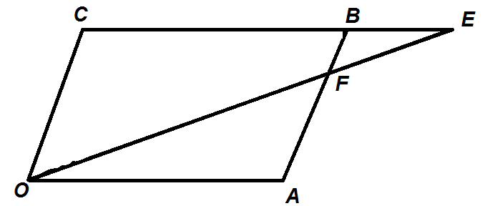

- Prove that ∆FOA and ∆FEB are similar

- Hence, deduce that F divides OE in the ratio 2:1.

- (3 marks)
Expand and simplify

- (m-n).(m-n)

- (c+d).(c+d)

- (m-4n).(3m-n)

- (8 Marks: 2, 1, 1, 4)
Given that $a=-4i+12j and b=10i-8j$, find:
- $\left|a+b\right|$

- The unit vector parallel to $a+b$

- A vector that is parallel to $a+b$, but with a magnitude of 10

- $a$ in terms of $p and q$ where $p=2i+j$ and $q=-3i+2j$

End of task

